1. **Issues**

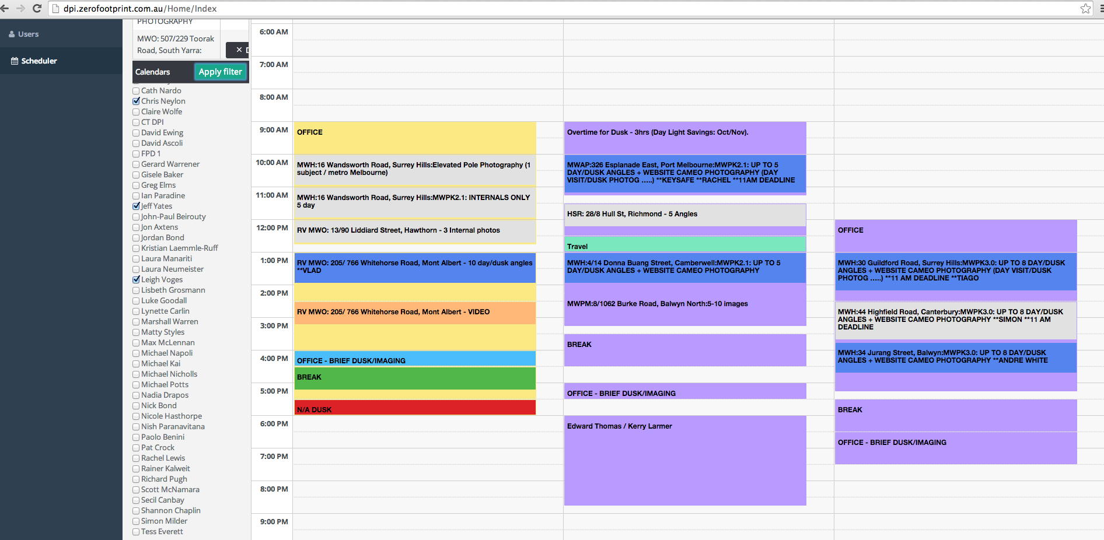

1.1

Client: The colours of the appointments need to apply to the full appointment, otherwise it looks too cluttered.

CK: I think there is a foreground and background colour for events and only one is being applied. It needs to colour the entire event with the product group colour.

1.2.

Client: Can we hide the 6-7am time slot.

CK: Ideally the non-business hours should be maintained in the db in the organization table and retrieved based on this ONCE on first login.

1.3.

Client: Are we able to scroll to evening slots without loosing the top rows with names and dates, this needs to be visible at all times:

CK> Like in excel with Frozen frames.



1.4.

Client: Can the columns be more compact when a large amount of calendars are selected?

CK> is there a way we can add a +/- button which the user can use to increase/decrease the width of calendars when viewing a large number of calendars?

1.5

Client: Can the time of the appointment show when hovering over the booking:  
  
Start Date/Time:

End Date/Time:

Duration:

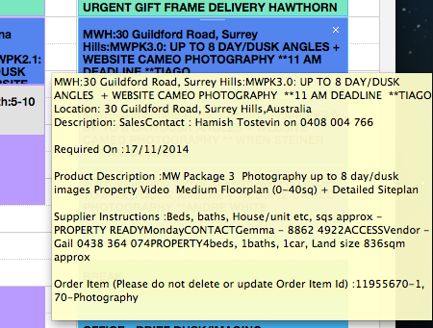

**2. Selections**

2.1

Client: Can we have two ways to select Photographers in a group?

* Fulltimers
* Freos

b) It would be good if first calendar view after log in could be:

Gerard

Jeff

Chris

Leigh

Marshall

Jordan

Jon

**3. Usability**

3.1

Client: The screen moves every first click you do in a new set up. Eg. if you select photographers for example and click anywhere in the calendars, the screen moves.

CK: Can you please check this.

3.2

Client: The calendar bookings still slot in at odd times. Can we ensure that when the events are created, the times are rounded to the nearest half/full hour?

CK:> When creating the events using the CT-DPI email service, the start time should be rounded to the nearest half/hour. This is a bug as this was working and requested from Swapnil, but regressed.

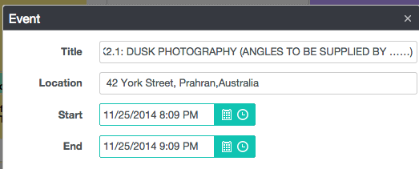

3.3

Client: The time and date currently has to be changed in both fields, it doesn’t adjust automatically as it does in outlook regarding length of appointment time. Is that an option?

CK: If the user changes the start time, or date, the end date should also move. Check in outlook how this works. It should mirror this behavior.

3.4

Client: Is page refresh possible without starting back from scratch? So need a refresh button without losing position?

3.5

Client: There is currently no print option of the appointments but we get often asked to print out the details. Is that an option?

3.6

Client: When we select colours for appointments manually, can it please read as the type of booking it is, rather than the name of the colour:

Dark Red – Dusk

Grey - Day Booking no Dusk

Dark Blue – Day Booking with Dusk

Orange – Video

Light Blue – Office

Yellow – Floorplans

Green – Travel

Purple - Personal

It will make it quicker to select

**4. Estimations:**

4.1

**Client: Search function for bookings**. We often get asked when a property was shot and it would be very handy to be able to search it and see all related bookings.

CK: Like in Google, have a search function that will query the events and display in Agenda mode. The search will search title, body and return those matching in Agenda view. Please check the search function in google calendar.